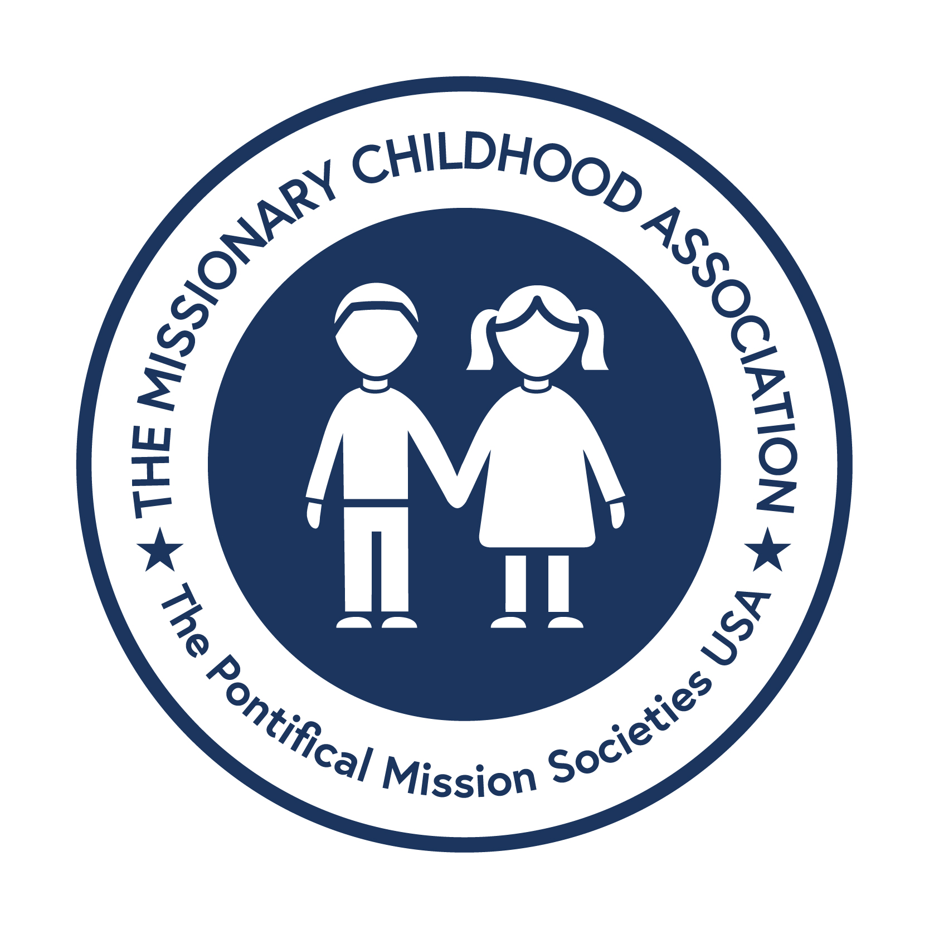
Missionary Childhood Association (MCA)
Official Christmas Artwork Contest Entry Form
Please print clearly. All fields must be completed.
Student Name: ________________________________________________________
Check one: □ Boy □ Girl
Check one: □ Catholic School □ Parish RE/CCD □ Home School
School / Home School / RE Program: _______________________________________________________________________
Grade: _________
Teacher / RE Director / Principal: _______________________________________________________________________
School or Parish Address: _______________________________________________
School or Parish Phone: _________________________________________________
(Arch)Diocese: _________________________________________________________
Home Address: _________________________________________________________
Parent or Guardian Name: _______________________________________________
Student Phone Number: _________________________________________________
Email Address: _________________________________________________________
Mail entries to: Office for Pro-Life and Missions, Catholic Pastoral Center, 1615 West Washington Street, Springfield, IL 62702 | Entries must be received by Thursday, January 15, 2026, no later than 5:15 p.m.

