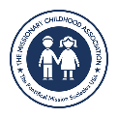
Christmas Art Contest
MISSIONARY CHILDHOOD ASSOCIATION

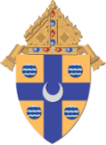Diocese of Springfield in Illinois –
Office for Pro-Life & Missions

💫 Why Does the Missionary Childhood Association Have a

Christmas Art Contest?

Jesus’ birth is God’s ultimate “missionary moment” — when the Word became flesh to live with us and bring Good News to the poor!

Pope Leo XIV, in Dilexi Te, said that “God became poor and was born like us” so we could see how near His love really is (§16). When children draw the Nativity, they tell the story of God’s love for everyone, especially the poor or forgotten. Every artist is a missionary when creating beauty shares Jesus with the world!

🎨 What is the Contest?
The Office for Pro-Life and Missions invites all Catholic schools and parish schools of religion programs to join the 2025–2026 MCA Christmas Artwork Contest! Students create art that celebrates the birth of Jesus and shows His love, joy, and missionary spirit.
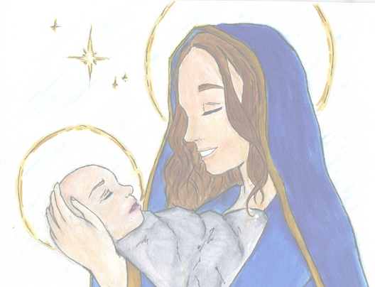
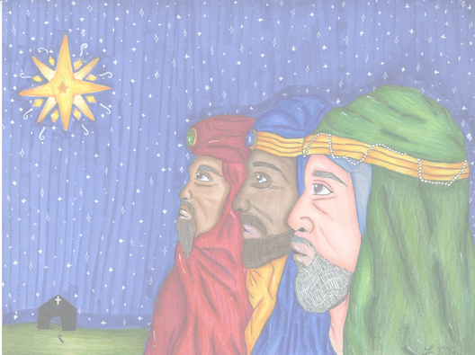
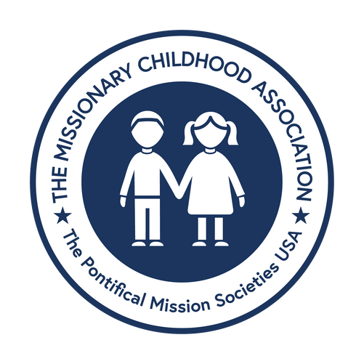
www. pontificalmissions.org

👧🏽 Eligibility & 🖼️ Contest Rules

Open to all Catholic students in grades K–8 in Catholic schools, parish programs, or homeschool.

• Each school or PSR may send 8 entries total — one boy and one girl from each group (K–2, 3–4, 5–6, 7–8).
🆕 New this year: only eight entries per school will be accepted.

• Artwork must be the student’s own work — no tracing or copying. 🚫
• Each drawing must have a completed entry form taped or glued (no staples, please).
✋ Don’t fold the artwork!
✏️ Write the student’s first and last name lightly in pencil on the back in case the form comes off.
• Once submitted, artwork will not be returned.
📬 The national MCA office may share winning artwork in publications or cards.

Paper & Materials
• Use 8½ × 11-inch white paper or card stock.
❌ No lined or construction paper.
💻 Digital copies are okay.
• Artwork must be drawn sideways (horizontal) — not up and down.
🚫 No vertical designs!
• Use crayons, markers, pastels, or watercolor paints.
❌ No lead or colored pencils.
• Do not add words or titles to the drawing.
• Use bright, bold colors and make faces and details clear so they show up well! 🎨

💡 Helpful Hints

Use bright, bold colors — they print best!
• Erase or cover pencil lines.
• Don’t write words or titles on the drawing.
• Fill most of the page but keep the main picture away from the edges.
• Make faces and features (eyes, nose, mouth) nice and clear.

⚠️ Important Note

Because we receive so many entries, we can’t return or personally acknowledge each submission — but every student’s work helps share the joy of Jesus’ birth!

✝️ Suggested Subjects
Students can pick one Christmas scene or subject to draw.
Here are some ideas:
• The Nativity – Baby Jesus, Mary, Joseph, and the animals in the stable 🐄🐑
• The Three Wise Men – bringing gifts or following the star 🌟
• The Shepherds – watching their sheep or visiting Baby Jesus 🐑
• Mother and Child – Mary holding Baby Jesus 💕
• Mary and Joseph Traveling to Bethlehem – on their long journey 🐴
• Newborn Jesus in the Manger – the Holy Family’s quiet moment ✨
• The Angel Gabriel – bringing the good news to Mary or the shepherds 👼
🖍️ Encourage students to make the scene bright, joyful, and full of life!

🏆 Recognition
Diocesan Level (our diocese):
• Winners: One boy and one girl from each group: K–2, 3–4, 5–6, 7–8.
• Judges: Curia staff — including Bishop Thomas John Paprocki.
• Celebration: Winners featured in The Catholic Times and honored at the Diocesan Mission Mass (October 2026). Families are warmly invited!

National Level (USA):
• Our 8 diocesan winners move on to the National MCA Contest.
• National MCA chooses 24 winners, including 2 grand-prize winners.
• Grand-prize art becomes the official Christmas card of the Pontifical Mission Societies; all national winners receive a plaque and national recognition.

📬 Submission Steps
- Hold a simple school/PSR contest to choose up to 8 finalists (1 boy + 1 girl from each group: K–2, 3–4, 5–6, 7–8). Use any easy method (art teacher pick, staff vote, etc.).
- Attach the MCA Entry Form to each artwork with tape or glue stick (no staples).
✏️ Write the student’s first & last name lightly in pencil on the back.
- Mail or deliver all finalists by 5:00 p.m. on January 15, 2026 (for diocesan judging).
Mail To:
Office for Pro-Life and Missions
Catholic Pastoral Center
1615 West Washington Street
Springfield, IL 62702

🌟 Teacher Tips
• Use big, bright color — light sketches don’t print well.
• Skip faint pencil outlines.
• Fill the page, leaving a small border.
• Keep it horizontal — no vertical designs.
• Remind kids why we make mission art: we’re sharing Jesus’ love with joy!

