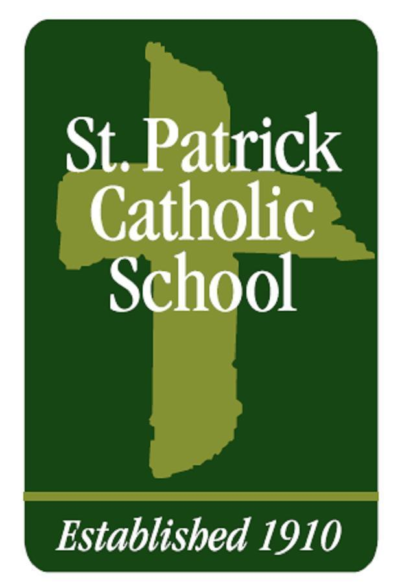
Seeking: 2024-25 Full-Time 2nd Grade Classroom Teacher

St. Patrick Catholic Elementary School in Springfield (st-patrick.org) is seeking an experienced certified Third Grade Classroom Teacher for the 24-25 school year:
- Competitive Salary and Benefits
- Right-sized classrooms (capped at 15 students)
- Hour-long lunch/planning period and additional AM and PM breaks for planning
- Must pass all required background checks and training

A micro-school whose mission is affordable education with high academic and character standards, St. Pat’s offers teachers close-partnership with families and a close-knit community of professional educators.

Please email a resume including references to: mcarlson@st-patrick.org
School Phone: 217-523-7670

