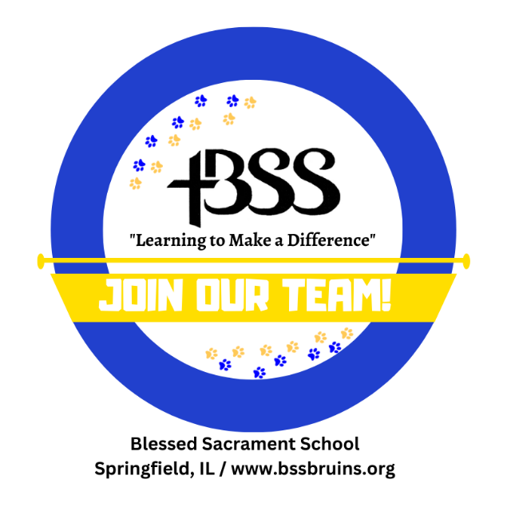
Blessed Sacrament School is a Catholic school located in Springfield, Illinois. Nearing its 100th anniversary, B.S.S. has provided hundreds of students with excellent academics, spiritual development, leadership skills, and numerous service and extracurricular opportunities. The current enrollment of the school is 427. Check us out to see how Blessed Sacrament students are “Learning to Make a Difference.”
Currently Available:
Full-Time Pre-K Teacher & Full-Time Kindergarten Teacher - Will instruct the 4-Yr-Old Pre-K or the Kindergarten classroom with a full-time aide. Applicants should hold a current Illinois Professional Educator's License. The ideal candidate will be a practicing Catholic who is knowledgeable about, and supportive of, the mission of Catholic education.
Full-Time Middle School Teacher - Applicants should hold a current Illinois Professional Educator's License. The ideal candidate will be a practicing Catholic who is knowledgeable about, and supportive of, the mission of Catholic education.
Preschool Aide - Full-time aide needed for all-day preschool classroom.
More Information & Application Direction:
